Experiment 6 #1

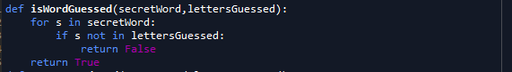



Experiment 6 #2

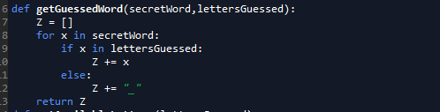



Experiment 6 #3

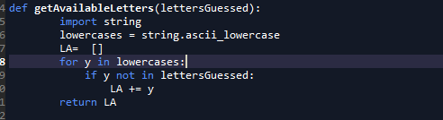

Experiment 6 #4

